Novice to Expert Scale

<https://www.nateliason.com/blog/become-expert-dreyfus>

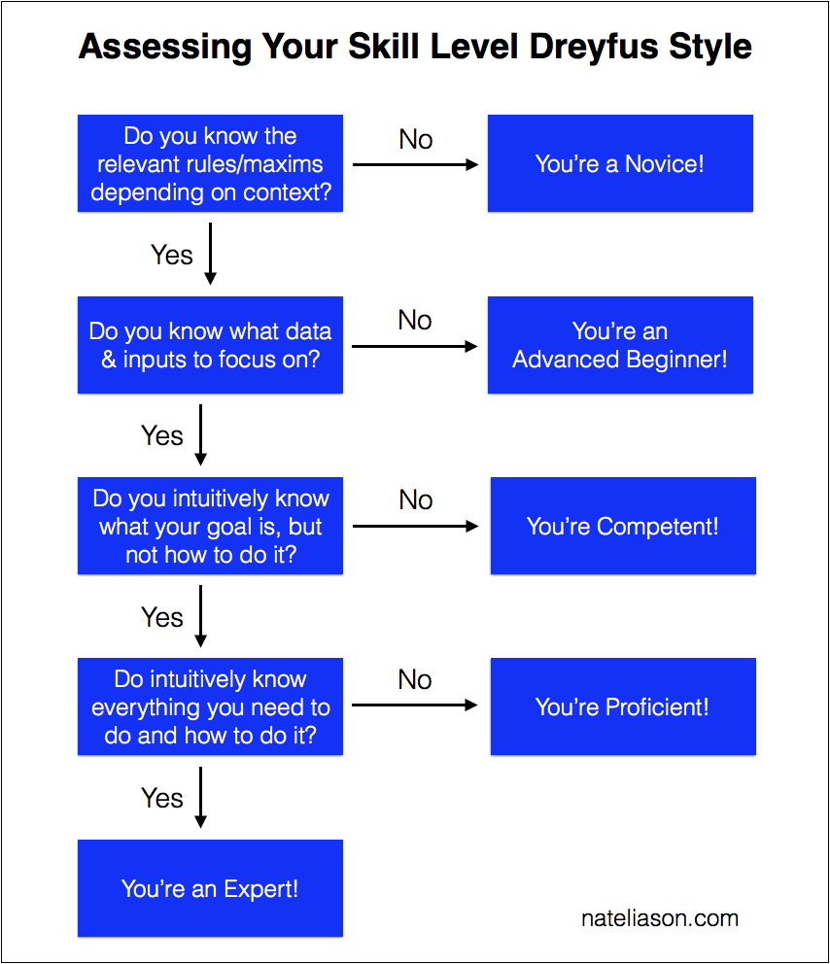

https://www.researchgate.net/figure/Benners-Novice-to-expert-model-of-skill-acquisition_fig1_329920427

